CERTIFICATE OF ACCURACY
STATE OF )
) ss:
COUNTY OF )

FIRST NAME LAST NAME, being duly sworn, deposes and says:

1. I translated the number-page source-language document headed “source title or other identifier” into the number-page target-language document headed “target title or other identifier,” both of which are attached hereto.

2. To the best of my knowledge, ability and belief, the said translation is a true, accurate and complete translation of the original source language document into the target language.

3. I am fluent in both languages. I have been a professional translator for how many? years and have been certified by the American Translators Association as a source-to-target translator since date, during which time I have maintained my certification in full force and effect.
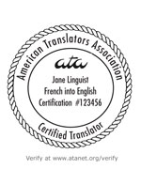

_______________________________________
SIGNATURE FIRST NAME LAST NAME, CT

Subscribed and sworn to before me
on this _______ day of ______, 2010.

__________________________________
NOTARY PUBLIC

Certification credentials may be verified online at www.atanet.org/verify.

