Certification of Accuracy
Re: Translation reference to source document name and number
I, FIRST NAME LAST NAME, hereby attest that I am a translator certified by the American Translators Association for source into target language, that I have translated the attached document, and that to the best of my knowledge, ability, and belief this translation is a true, accurate, and complete translation of the original source language document that was provided to me.

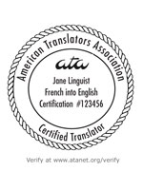
__________________________________
SIGNATURE FIRST NAME LAST NAME, CT

_________________________________
DATE

Certification credentials may be verified online at www.atanet.org/verify.

